Department of Computer Science and Engineering
B
Midterm Examination Spring 2023
CSE 321: Operating Systems
Duration: 1 Hour 15 Minutes | Total Marks: 25
Answer the following questions.
Figures in the right margin indicate marks.

1.  CO1 | a) Briefly explain dual mode operation of OS.  b) Distinguish between layered and microkernel OS structures.  c) Two processes (A and B) are distributed across multiple physical machines or networked systems. Which technique can be used to achieve inter-process communication in this scenario? Is it suitable for exchanging large amounts of data? Provide proper justification to support your answer.  d) Find the output of the following code snippet.  const int len = 2;  int main(){  int id;  int a[] = {5,8};  int b = len-1;  id = fork();  if (id < 0){  printf("fork failed\n");  }  else if(id > 0){  wait(NULL);  printf("parent process executing\n");  }  else{  printf("child process executing\n");  a[b-1]=a[b-1]+2;  a[b] = a[b]-3;  }  for(int i=0;i<len;i++){  printf("value of a[%d]: %d\n",i,a[i]);  }  return 0;  } | [2]  [3]  [2]  [3]
2.  CO2 | Processes Arrival Time Burst Time  P1 0 11  P2 20 6  P3 14 9  P4 20 8  P5 15 8  P6 16 8  P7 2 2  a) Draw a Gantt chart and illustrate the execution of the process using the Round Robin scheduling algorithm (time quantum = 5 units). Calculate the average waiting and turnaround time, | [3+2]
 | b) Apply Shortest Remaining Time First (SRTF) scheduling algorithm. Draw the Gantt chart and Calculate the average waiting and turnaround time.  c) Compare the results and identify the most suitable scheduling algorithm in this scenario. | [2+2]  [1]
3.  CO3 | a) A system has processes to execute of which 45% is parallel. If the number of cores is increased from 2 to 4, Explain what will be the increase/decrease in performance.  b) Describe the multithreading model which is shown in the picture below. Identify the issue in this model and suggest another multithreading model which is free from that issue.  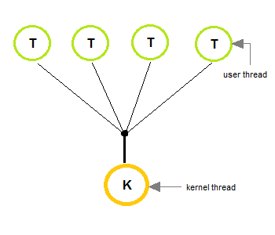 | [2]  [3]

